Smart wiper control system

**Introduction:**

Wiper is an essential component that used to wipe the raindrops or any water from the windscreen. Wipers are designed and made to clear the water from a windscreen. Most of cars have two wipers on the windscreen, one on the rear window and the other on each headlight. The wiper parts visible from outside the car are the rubber blade, the wiper arm holding the blade, a spring linkage, and parts of the wiper pivots. The wiper itself has about six parts called pressure points or claws that are small arms under the wiper.

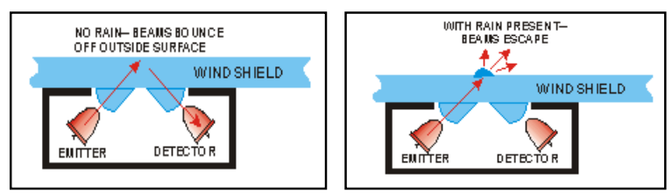

Existing system manually used control stalk to activate wiper and the process of pulling up wiper is difficult to be handled. The driver needs to switch on and off the control stalk and it will reduce the driver’s concentration during the driving. Thus, this system is proposed to solve all these problems. The concept of this wiper system is similar with other conventional wiper, yet this system will be upgraded to an automatic control system by using a controller. Whenever the water hit a dedicated sensor that located on windscreen, it will send a signal to move on the wiper motor. Once water is not detected by sensor, the wiper will automatically stop. This will help the driver to give more concentration and reduce the car accident probability. In this project, there were two innovations reviewed as the literature review. The two were designed with different concept and operating mechanism however with same objective of working principle of the car wiper. The rain sensor was a highly versatile device for automatic wiping of vehicle windscreen when it is wet due to moisture, raindrops or even mud . It worked by reflecting harmonious light beams within the windscreen. When raindrops fall onto the windscreen, this harmony light is been disturbed and creating a drop in the light beam intensity. The system then activated the wipers to be operated in full automatic mode. It has a response time at 0.1 seconds. It allowed for a quick reaction when it is a sudden splashes of water that will make the driver totally ‘blinds’ when the situation happened. With the automatic wiper, the driver can avert from the risk of an accident. The automatic wiper is important during the heavy traffic e.g. in town, city, school zone and other public place. A driver may be subjected to many distractions with bad weather, dangerous road conditions and fatigue. The Rain Sensor reduced the driver’s burden by making the driving more comfortable. Trailing a wet car is no longer a nuisance as detection of even 0.005 milliliters of water is possible.

From the literature review, it is found that the disadvantage of these products is expensive and else sensitive when the beam is disturbed. This system used the light beam to sense the water hitting. Further, these products were suitable for the country with four seasons and not suitable for the country with hot and climate wheatear. Hence, this project proposed a microcontroller to be used to execute the function of this system. By using Peripheral Interface Controller (PIC) microcontroller, the controller can be programmed using C language or assembly language. The project will be the combination of three circuits with a main control system. The objectives of this project are to upgrade the older cars system and design a suitable program that will fully operate with the system. The system will provide the automatic wiping system and prevent the wiper’s rubber from damage and contribute lifetime increases.